**Assisted Practice: 3.2 Change the Volume Size of an Instance**

This section will guide you to:

* Change the volume size of an instance

This lab has seven subsections, namely:

3.2.1 Creating the new volume which we want to add to an instance and clicking on **create volume**

3.2.2 Validating the Availability zone of the EC2 instance with which you want to add volume

3.2.3 Providing type, size, availability zone, and snapshot name on the **create volume** tab

3.2.4 Selecting newly created volume and clicking on the action to attach the volume to the instance

3.2.5 Selecting the instance of the same availability zone and attaching the volume in pop

3.2.6 Verifying the instance by adding one more device to the block device

3.2.7 Pushing the code to GitHub repositories

**Note:** By default, when we create a new instance, we need to attach the minimum volume to the instance depending on the OS or AMI. But we can also add or remove the volume.

**Step 3.2.1:** Creating the new volume which we want to add to an instance and clicking on **create volume**

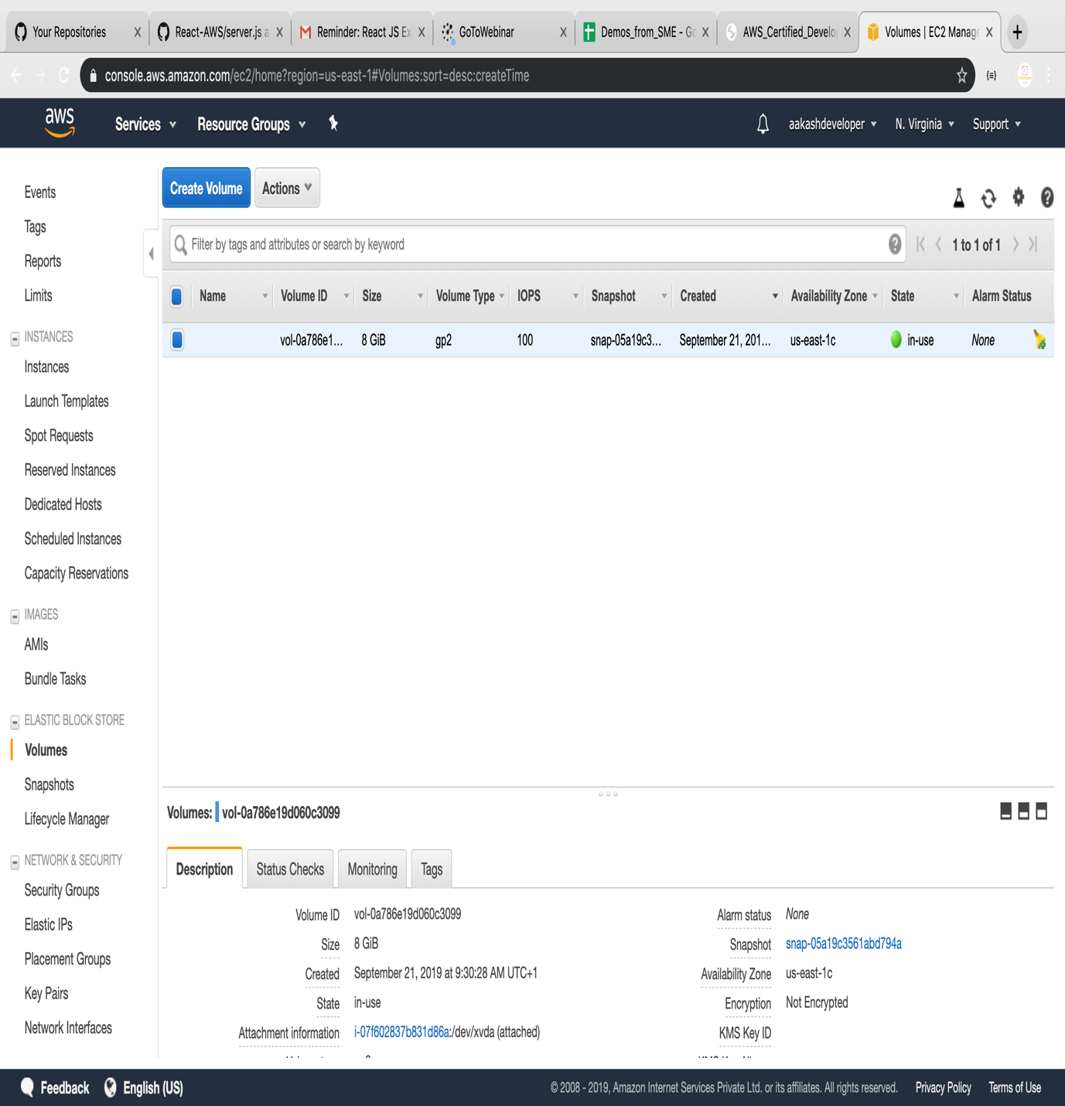

**Step 3.2.2:** Validating the Availability zone of the EC2 instance with which you want to add volume

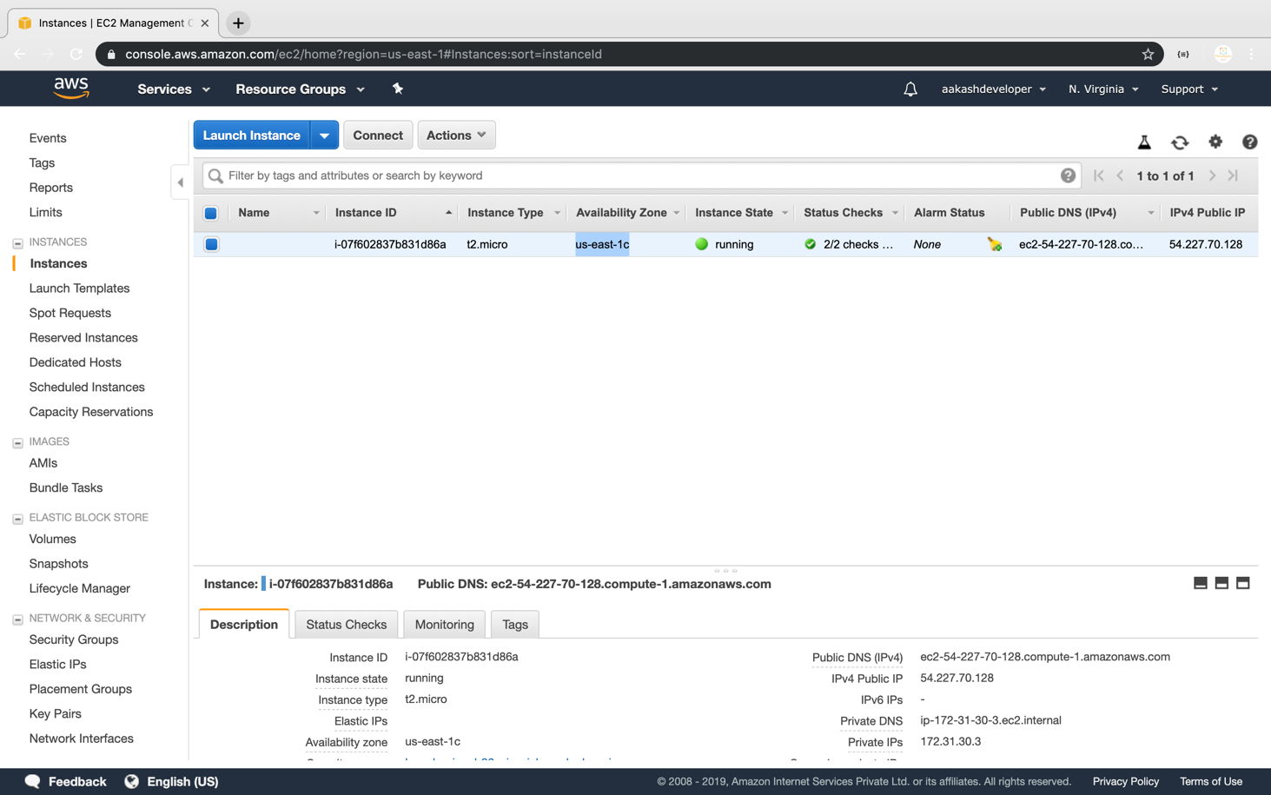

**Step 3.2.3:** Providing type, size, availability zone, and snapshot name on the **create volume** tab

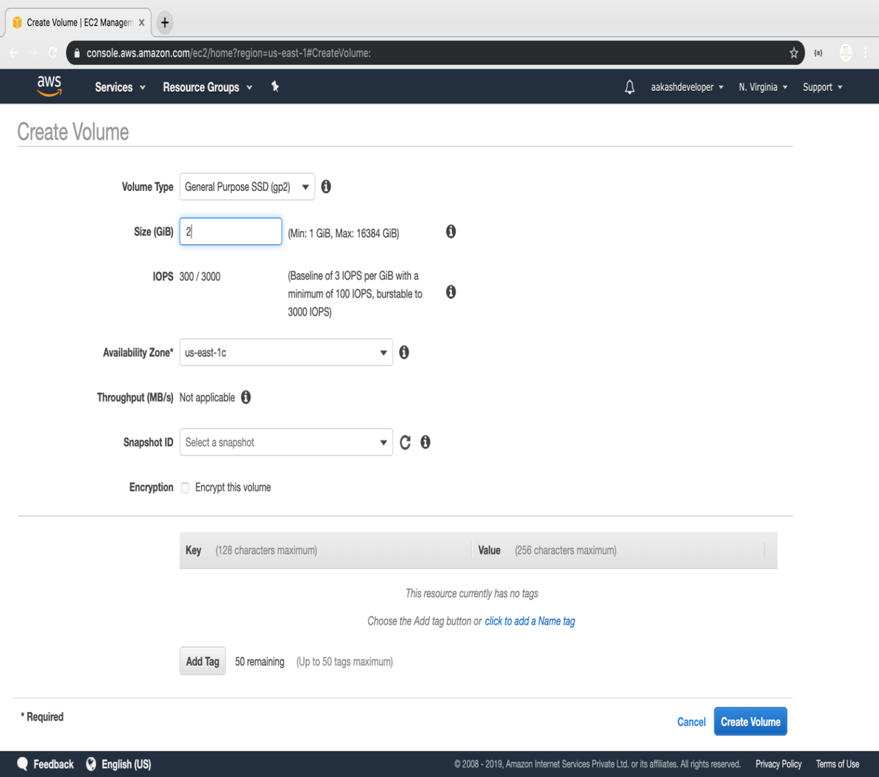

**Step 3.2.4:** Selecting newly created volume and clicking on the action to attach the volume to the instance

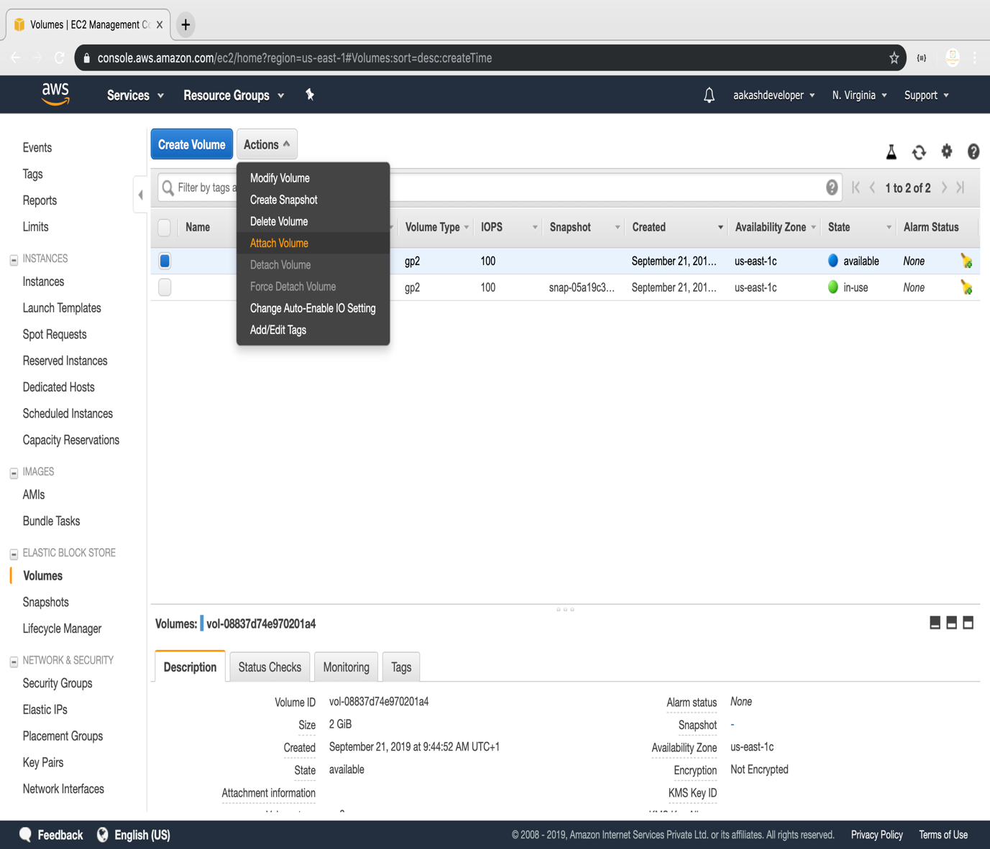

**Step 3.2.5:** Selecting the instance of the same availability zone and attaching the volume in pop

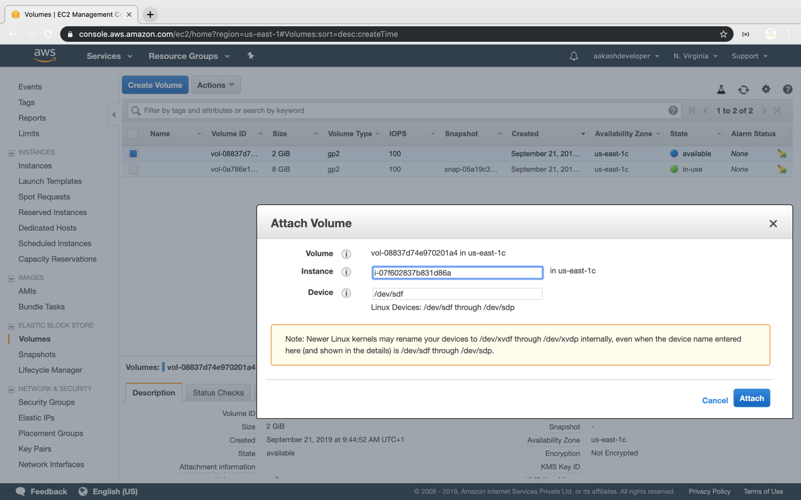

**Step 3.2.6:** Verifying the instance by adding one more device to the block device

